**GNS3 Lab Setup [v2.2.31]**

**GNS3 Client Host Hardware Information:**

Below table shows the GNS3 client hardware information.

Table - GNS3 Client Host Hardware Info

|  |  |
| --- | --- |
| Hardware | Hardware Details |
| Model | Dell XPS 15 9570 |
| CPU | Intel(R) Core(TM) i7-8750H CPU @2.20GHz, 2208Mhz 6 Core(s), 12 Log- ical Processor(s) |
| RAM | 16 GB |
| NIC | Network Controller - Realtek GbE Family Controller, Killer Wireless-n/a/ac 1535 Wireless Network Adapter |

**GNS3 Client Host Software Information:**

The table provides software and ip address information.

|  |  |
| --- | --- |
| Software | Software Details |
| OS | Microsoft Windows 10 Enterprise |
| Lab Setup | GNS3 Client |
| Client Version | GNS3 2.2.31 |
| IP Address [LAN] | 192.168.1. 11 |
| IP Address [Wi-Fi] | 192.168.1.9 |

Table - GNS3 Client Host Software Info

**GNS3 Remote Server Hardware Info:**

The table shows GNS3 remote server hardware information.

|  |  |
| --- | --- |
| Hardware | Hardware Details |
| Model | Dell Precision M4700 |
| CPU | Intel(R) Core(TM) i7-3740QM CPU @ 2.70GHz |
| RAM | 32GB |
| NIC | Network controller - Broadcom Inc. and subsidiaries BCM4313 802.11bgn Wireless Network Adapter |

Table - GNS3 Remote Server Hardware Info

**GNS3 Remote Server Software Info:**

The below tables shows the software information for GNS3 Remote Server.

|  |  |
| --- | --- |
| Software | Software Details |
| OS | Ubuntu 20.04.4 LTS (GNU/Linux 5.13.0-35-generic x86 64) |
| Lab | GNS3 Server |
| Version | Version 2.2.31 |
| IP Address  [LAN] | 192.168.1.17 |
| IP Address  [Wi-Fi] | 192.168.1.12 |
| QEMU  Emulator  Package | Qemu-system-x86 |
| QEMU Version | 1:4.2-3ubuntu6.21 |
| Dynamips | Cisco Router Simulation Platform (version 0.2.21-amd64/Linux stable) |

Table - GNS3 Remote Server Software Info

**Home Lab Setup:**

**

Figure – Home Lab Setup

Adding GNS3 Remote Server to GNS3 Client.

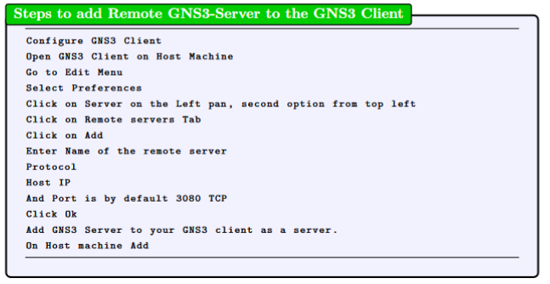

Figure - Add GNS3 Server to GNS3 Client

Figure 3 shows the dialogue box on GNS3 client to add remote server.

Figure - Add GNS3 Server - GNS3 Client Preferences

**GNS3 Remote Server Setup:**

Commands to install gns3 on remote server, step by step guide.

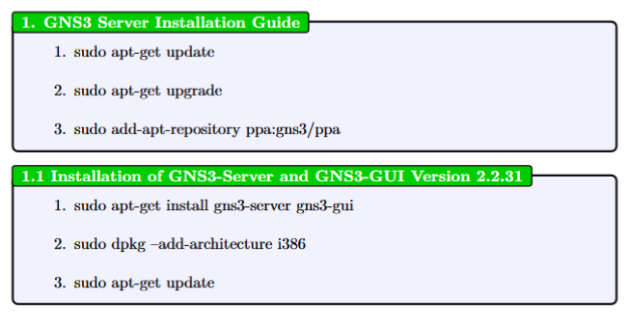

Figure -GNS3 Server Installation Guide

**Add IOU Support and Installation, Docker CE Installation :**

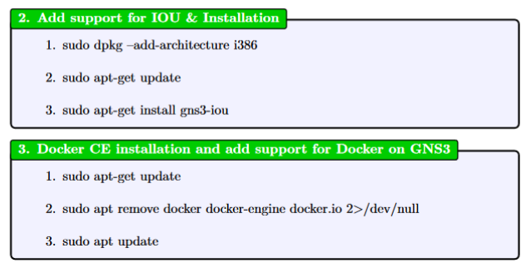

Figure IOU & Docker Installation

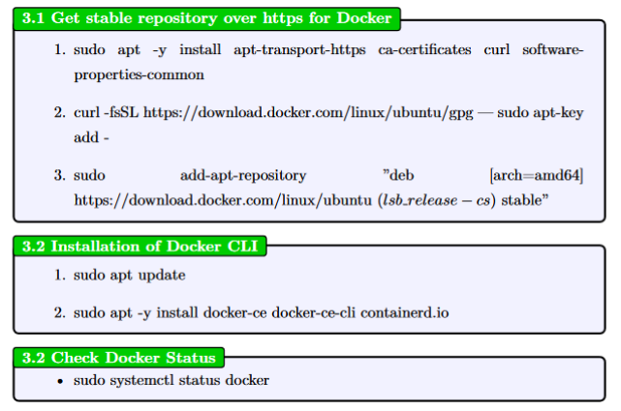

Figure - Docker repository and CLI and Status check

Just make sure the docker is running on GNS3 remote server.

Figure - GNS3 Docker Service Status

After installation of we need to make some modification to the groups and create GNS3 service and configure GNS3 server as a service.

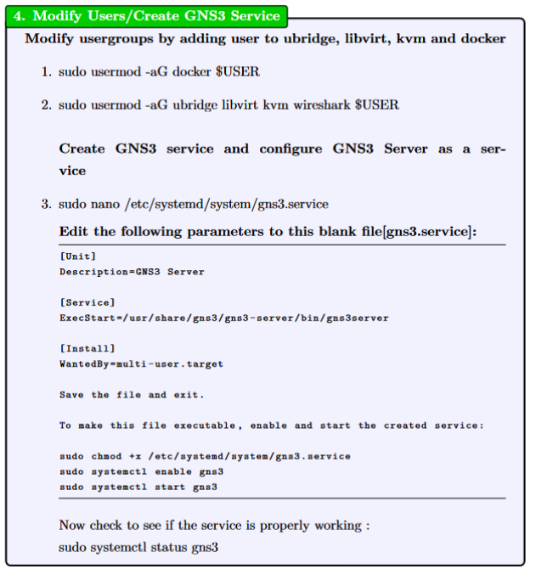

Figure - GNS3 Service & Configuration

GNS3 Service Status:

Figure - GNS3 Server Status Check

**GNS3 Client Host, GNS3 VM Server & GNS3 Remote Server[netlab]:**

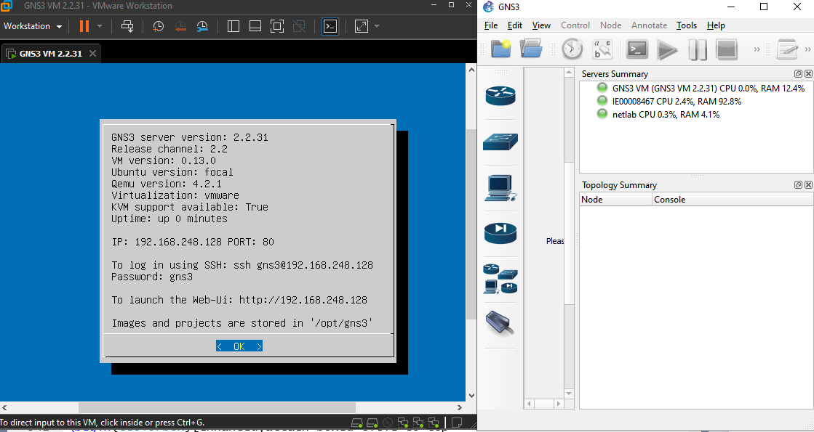

**GSN3 Server – Web- User Interface:**

